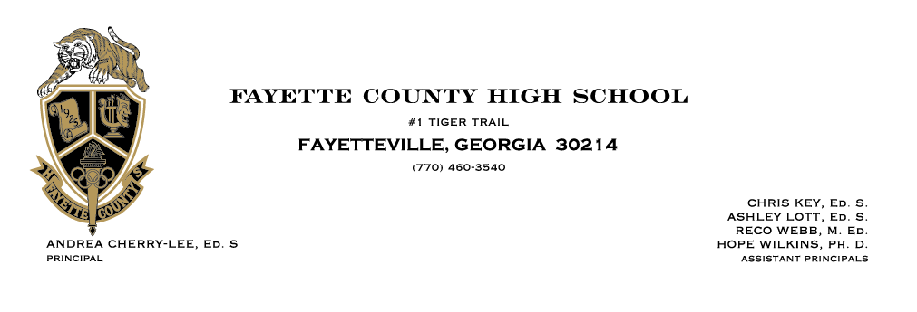

**PROM GUEST PERMISSION FORM 2025**

***Saturday, March 29th, 2025***

***Porsche Experience Center, 1 Porsche Dr, ATL, GA 30354***

Prom is a memorable and special night for FCHS students. These guidelines are intended to ensure that all students are able to have a safe and enjoyable evening.

**Prom Guidelines:**

**Procedure**

● Students will enter the prom upon arrival at the prom premises and leave the prom premises immediately at the end of the prom.

● Students will NOT be allowed to reenter the prom once they have left the premises.

● Only FCHS students and their approved guests are allowed in the prom.

● Students and guests must show identification. (School Identification w/picture or Government Issued Identification are acceptable)

● Students and guests must enter and leave together.

**Dress Code**

● The best presentation is a **dress shirt, tie, and slacks** or a **formal or semi-formal dress**. No JEANS!!! Clothing should provide appropriate coverage even while dancing. Dress/attire should be in good taste. Students wearing dresses/attire that is too provocative or revealing will not be permitted to enter.

**Behavior**

● **No alcohol or drugs** are allowed at FCBOE functions, including dances. Any attendee suspected of being in possession of (or having consumed) alcohol or drugs, will not be allowed to enter the dance, and the proper authorities will be notified.

● Dancers’ hands will be kept in an appropriate place, and dancers will be expected to display decency at all times.

● No grinding, wall dancing, slam-dancing, mosh-pits, back to front dancing, or “dirty dancing,” or dancing in a manner in which bodies are touching in a sexually suggestive way.

**To be completed by FCHS Student and Parent/Guardian**

I will adhere to the dress code, standards for activities, and dance guidelines as outlined above. I understand that if I choose to violate these, I will be asked to leave prom and will not receive a refund.

This page with the necessary signatures must be turned in two weeks prior to the purchase of a guest ticket. Signatures below indicate that you and your parents/guardians acknowledge and agree to the dance guidelines as outlined above. FCHS Student Name (Print First and Last Name):



Student :____________________________________________________________________________________________



Signature: FCHS Parent/Guardian Name (Print First & Last Name): _____________________________________________



Parent/Guardian Signature: ______________________________________________________________________________



**\*\*\*\*\*\*\*\*\*\*\*\*\*\*\*There will be no refunds or exchanges on tickets. All sales are final. \*\*\*\*\*\*\*\*\*\*\*\*\*\*\*** *Guest Permission Slip*

**You must have this form completed and approved before you can purchase a ticket for your guest.**

➢ Proper attire and photo identification are required at the door.

➢ No student who attends middle school or individuals 20 or older will be allowed admittance.

➢ Guests must adhere to all dance guidelines provided on the reverse side of this form.

➢ FCHS students and guests must enter and leave prom at the same time. FCHS student is responsible for his/her guest.

➢ Please print neatly except for requested signatures

**A. Information about Fayette County High School Student**

|  | **SCHOOL EVENT** | 2025 FCHS Prom on Saturday, March 29th, 2025, at 7 - 11 pm | |
| --- | --- | --- | --- |
| FCHS Student  Parent/Guardian  Telephone Number | *Print Name:*  *Print Name:*  *Primary:* | *Grade/Signature:*  *Signature:*  *Secondary:* |

**B. Information about the guest who does not attend FCHS**

|  | **SCHOOL EVENT** | 2025 FCHS Prom on Saturday, March 29th, 2025, at 7 - 11 pm | |
| --- | --- | --- | --- |
| GUEST Student School | *Print Name:* | *Grade:* |
| GUEST Student Name GUEST Parent/Guardian | *Print Name:*  *Print Name:* | *Signature:*  *Signature:* |
| GUEST Parent Phone  Number | *Primary:* | *Secondary:* |

**C. To Be Completed by FCHS student’s guest**

I agree to respect and abide by all rules, regulations, policies, and dance guidelines for the Fayette County High School Prom.

**Signature of FCHS student’s guest Date: ________________________________________________________________**

**D. To Be Completed by Guest’s High School Administrator**

Please indicate the status of this individual (listed in Section B) at your high school or place of business. If you have any questions, please contact the FCHS Principal or Assistant Principal at 770-460-3540. Thank You.

This individual is in “good standing” at our school

This individual is not in “good standing” at our school/

Please contact me regarding this individual(Contact number )



Printed Name of Administrator/Employer: __________________________________________________________________



Signature of Administrator/Employer Date: _________________________________________________________________

**E. To Be Completed by FCHS Administrator (if a guest is in college)**

I give permission for the above named college student to attend the Fayette County High School prom providing they agree to respect and abide by all rules, regulations, policies, and dance guidelines for the Fayette County High School prom.



Printed Name of FCHS Administrator: __________________________________________________________________________



Signature of FCHS Administrator Date: _________________________________________________________________________